Infosys Springboard Virtual Internship 6.0 Completion Report

Team Details
Batch : 13
Start date – 02/02/2026
Names:
Maganti Anil Kumar
DHANUSH T
Varsha D
Kancharla Hema Bhanu Sri
Navya lohita Tirumalapudi
Zainabh
BONDAR PRATAP DATTU
Internship Duration: 8 Weeks

1. Project Title
HotelRevAI – AI Driven Revenue Analysis for Hotels.

2. Project Objective
- To analyze hotel booking and revenue data in a systematic and meaningful way.
- To help hotels understand booking patterns and customer behavior.
- To study revenue generation, cancellation trends, and occupancy performance.
- To convert raw booking records into useful business insights using data analytics and Power BI.
- To support smarter and more effective decision-making for hotel management.
- To improve hotel revenue management through intelligent data analysis.
- To calculate important KPIs such as Total Revenue, Total Bookings, Average Stay, Occupancy Rate, Cancellation Rate, ADR, and RevPAR.
- To help hotel managers plan better pricing strategies.
- To reduce revenue loss caused by booking cancellations.
- To improve the overall performance and profitability of hotels.

3. Project description in detail
HotelRevAI is an AI-driven revenue analysis system developed for the hotel industry to analyze booking data and generate useful business insights. Hotels receive a large volume of booking data from sources such as direct reservations and online travel agencies, making manual analysis difficult, time-consuming, and less accurate. To solve this problem, the project was developed using Power BI to transform raw hotel booking data into meaningful information for better decision-making.
The project uses a hotel booking dataset in which each row represents a single booking record. It includes important details such as hotel type, cancellation status, lead time, arrival date, number of guests, stay duration, and ADR. The data was imported into Power BI, where Power Query Editor was used to clean and transform it by correcting data types, removing missing and duplicate values, renaming columns, and formatting dates properly. After cleaning, a star schema data model was created with the Booking table as the fact table and Hotel, Customer, and Date as dimension tables.
DAX was used to create important measures such as Total Revenue, Total Bookings, and Average Stay, along with other KPIs like Occupancy Rate, Cancellation Rate, ADR, and RevPAR. The final stage focused on data visualization and storytelling using charts, KPI cards, and dashboards. These visuals helped present booking trends, revenue patterns, and hotel performance clearly. Overall, the system helps hotel managers forecast demand, plan pricing strategies, reduce cancellations, improve occupancy, and increase profitability.

4. Timeline Overview
Week | Activities Planned | Activities Completed
Week 1 | Understanding project topic and problem statement | Studied hotel revenue analysis concept and identified the project scope.
Week 2 | Dataset collection and understanding columns | Collected hotel booking dataset and analyzed important fields such as hotel type, ADR, cancellation status, and arrival date.
Week 3 | Data cleaning and preprocessing | Cleaned the dataset using Power Query, corrected formats, and removed missing/duplicate values.
Week 4 | Data modeling design | Created star schema model with fact and dimension tables.
Week 5 | DAX calculations and KPI creation | Created measures like Total Revenue, Total Bookings, and Average Stay.
Week 6 | Dashboard design | Developed visual reports
Week 7 | Insight generation and data storytelling | Interpreted the data, identified trends, and prepared meaningful insights.
Week 8 | Final review and presentation preparation | Finalized the dashboard, reviewed project outcomes, and prepared presentation.

5a. Key Milestones
Milestone | Description | Date Achieved
Project Kickoff | Started internship project and understood the problem statement | 5-02-2026
Prototype/First Draft | Completed initial data cleaning and created basic dashboard draft | 11-02-2026
Mid-Term Review | Reviewed progress in data modeling, DAX, and KPI implementation | 20-02-2026
Final Submission | Completed dashboard and report documentation | 13-03-2026
Presentation | Presented HotelRevAI project findings and outcomes | 24-03-2026

5b. Project execution details
The HotelRevAI project was executed in multiple structured stages to ensure proper analysis of hotel booking and revenue data. First, the team understood the main problem faced by hotels in handling large volumes of booking records. A suitable hotel booking dataset was selected, and its columns were studied carefully to understand their business relevance. The dataset, which included details such as hotel type, stay duration, arrival date, cancellation status, and ADR, was then imported into Power BI. Using Power Query Editor, the data was cleaned and transformed by correcting data types, removing missing and duplicate values, renaming columns, and organizing the dataset for accurate analysis.
After preprocessing, a star schema data model was created with the Booking table as the fact table and other related tables as dimension tables. Proper relationships were established to improve performance and support efficient analysis. DAX measures were then developed to calculate important KPIs such as Total Revenue, Total Bookings, and Average Stay. In the final stage, charts, KPI cards, and dashboards were created to visually present revenue trends, booking behavior, and overall hotel performance. The project was completed by combining data visualization with storytelling, followed by final analysis, report documentation, and presentation.

6. Snapshots / Screenshots

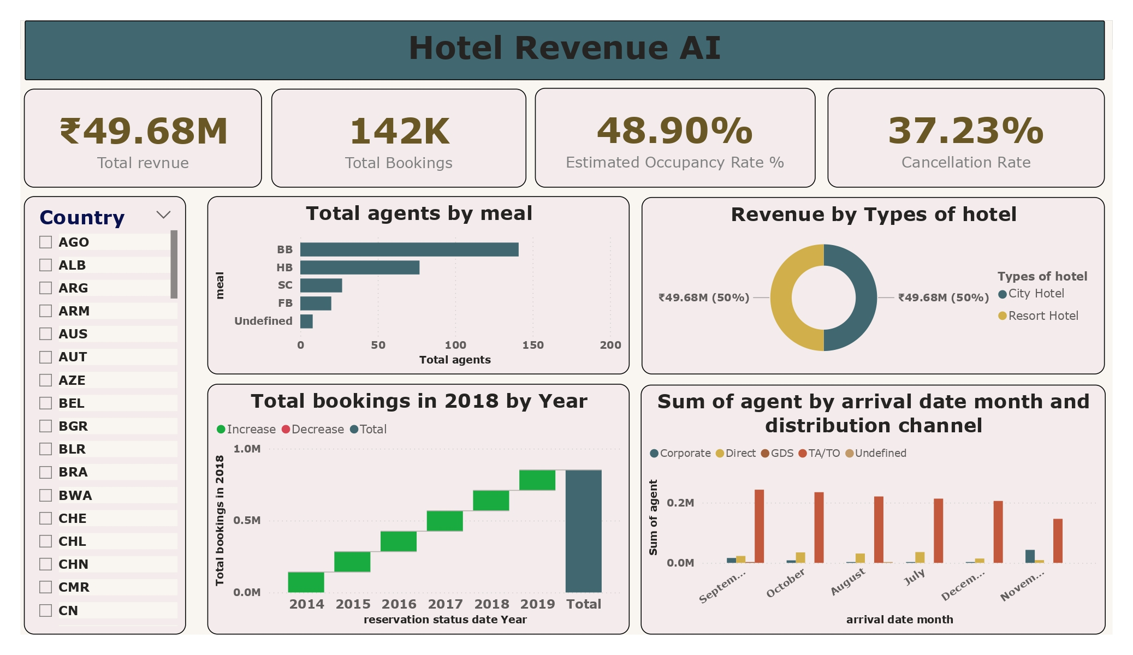

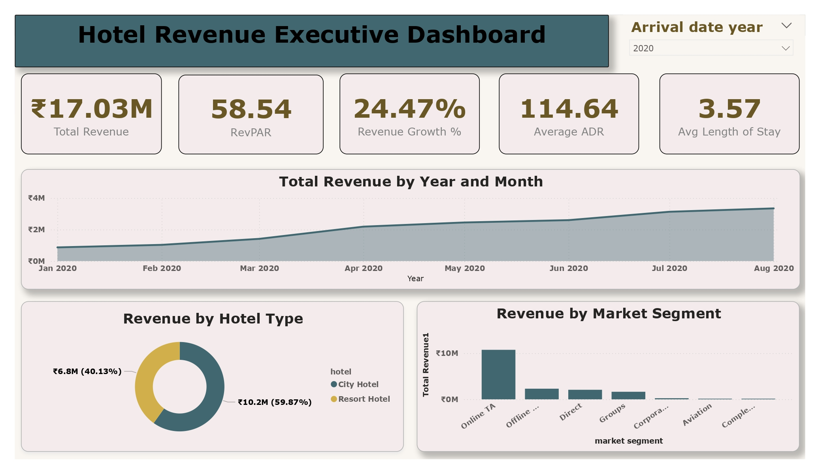

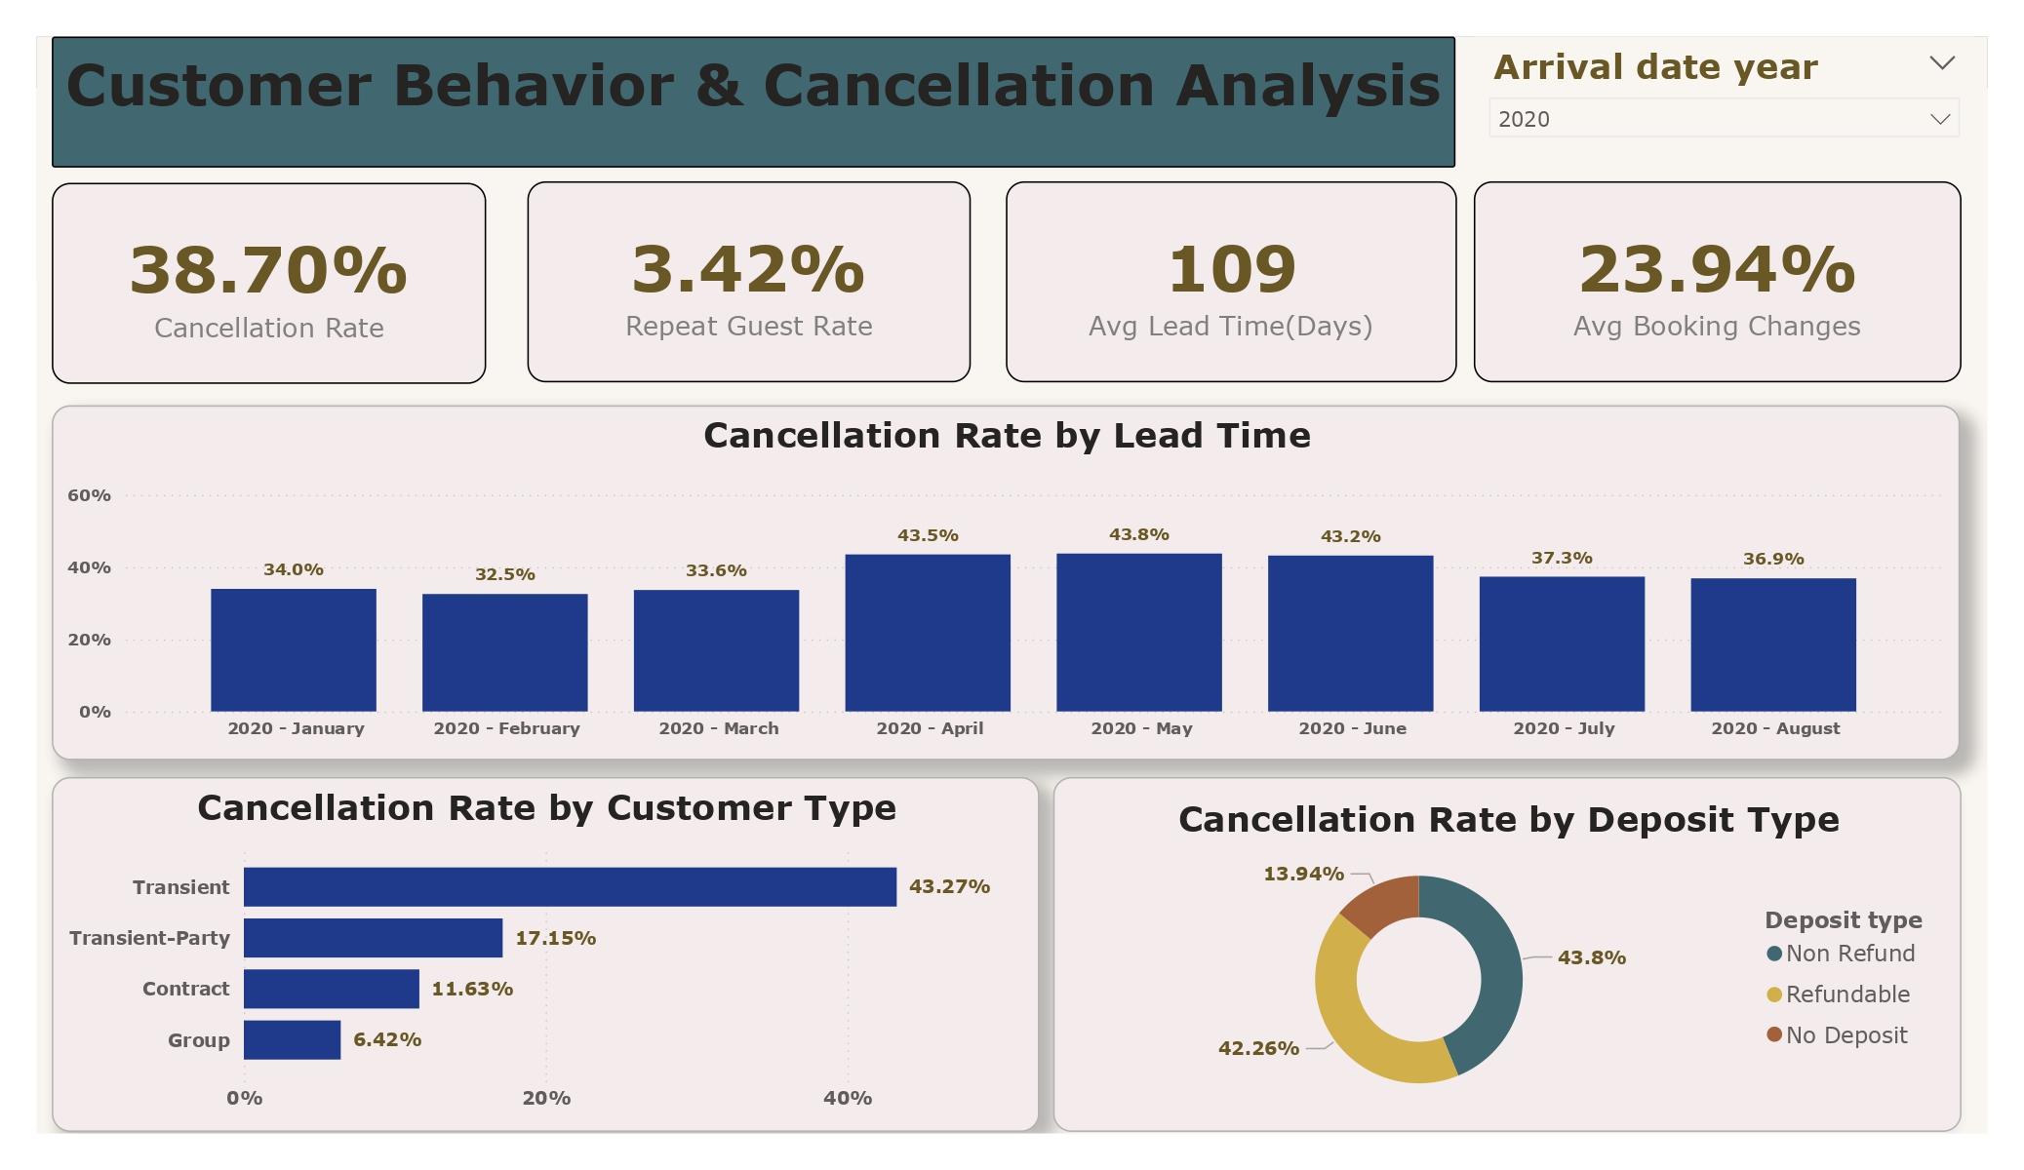

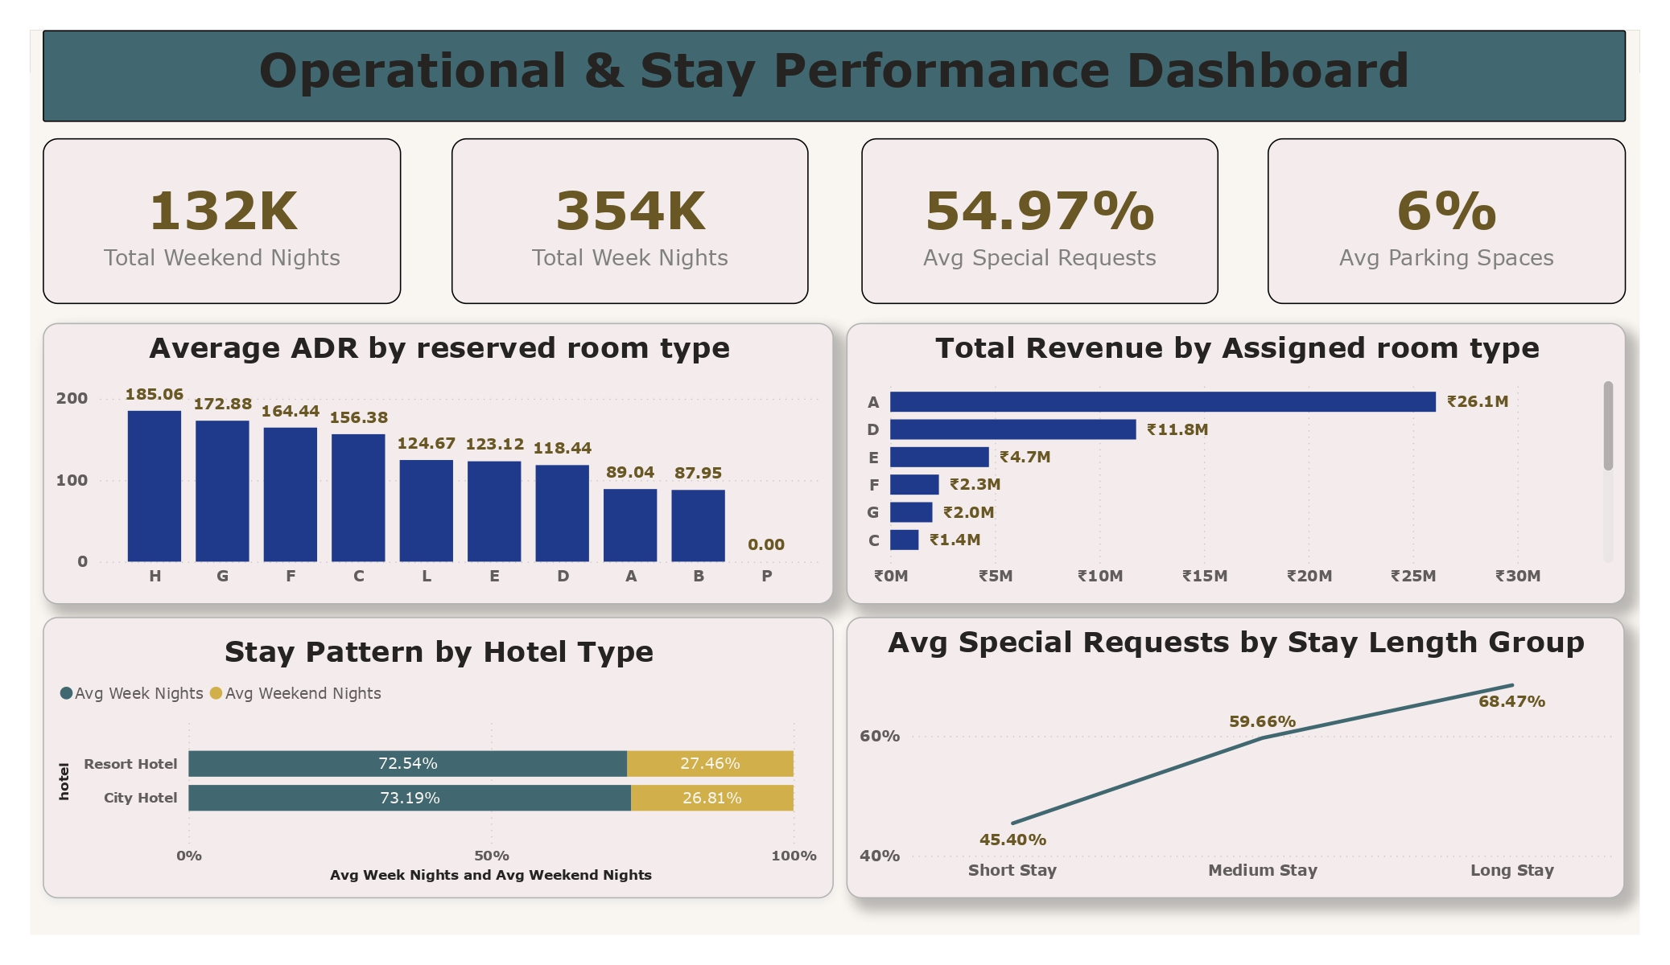

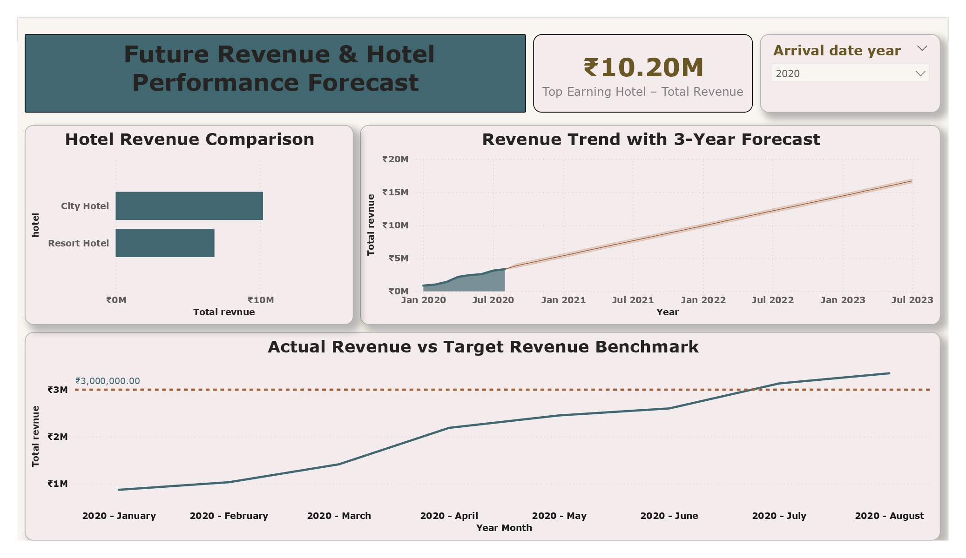

7. Challenges Faced
One of the major challenges faced during this project was handling a large volume of booking data and identifying the most relevant fields for revenue analysis. Cleaning the data was also challenging, especially when correcting data types, fixing date formats, and removing missing or duplicate values. The team further faced difficulties in designing an effective data model, selecting the right KPIs, and creating DAX measures based on proper business logic. Another challenge was presenting the analysis in a visually simple yet informative way. These challenges were overcome through repeated testing, careful data validation, teamwork, and continuous improvement of the dashboard design.

8. Learnings & Skills Acquired
- Gained both technical and analytical skills through the internship.
- Learned to work with real-world datasets.
- Performed data cleaning using Power Query in Power BI.
- Improved understanding of data modeling concepts such as star schema, fact tables, dimension tables, and table relationships.
- Learned to create DAX measures and calculated columns for business analysis.
- Developed skills in dashboard design and data visualization.
- Learned how to present complex data in a simple and meaningful way.
- Used charts, KPI cards, and dashboards for storytelling and insight presentation.
- Improved problem-solving ability through project work.
- Developed teamwork, communication, and presentation skills.
- Gained practical exposure to the use of business intelligence tools in the hotel industry for revenue management.
.

9. Testimonials from team
Working on the HotelRevAI project was a valuable and enriching experience for our team. It gave us an opportunity to apply theoretical concepts of data analytics and Power BI in a practical business scenario. We were able to understand how hotel booking data can be transformed into meaningful insights for revenue improvement and decision-making.
This internship also helped us improve our collaboration, technical confidence, and presentation skills. Each team member contributed to different aspects of the project such as data preparation, KPI calculation, dashboard design, and content preparation. Overall, this project was a great learning journey that enhanced our knowledge of business intelligence and real-world data analysis.

10. Conclusion
The Hotel Revenue Analysis project was successfully developed using Power BI to analyze hotel booking data and generate meaningful business insights. Through data cleaning, modeling, DAX calculations, and dashboard creation, the project helped in understanding important hotel performance indicators such as revenue, bookings, and average stay. The use of visualizations made the analysis simple, interactive, and easy to interpret.
Overall, this project demonstrated how intelligent data analysis tools can help hotels make better decisions, improve operational efficiency, and increase revenue. The internship provided valuable practical exposure and helped bridge the gap between academic learning and real-world implementation. It also aligned well with our career interests in data analytics, business intelligence, and technology-driven problem-solving.

11. Acknowledgements
We would like to express our sincere gratitude to Infosys Springboard for providing us with this valuable internship opportunity. This internship helped us gain practical exposure to data analytics, Power BI, and business intelligence concepts in a real-world problem domain.
We would also like to thank our mentors, guide Selciya Mam and team members for their continuous support, encouragement, and valuable suggestions throughout the project. Their guidance helped us successfully complete the HotelRevAI project and gain confidence in applying data-driven approaches to business problems.

